**U.S. Department of Energy (DOE)  
Clean Energy to Communities (C2C) Program**

Summary of Technical Assistance (TA) Support

|  |
| --- |
| Marker with solid fill |
| Icon  Description automatically generatedBuildings |
| Icon  Description automatically generatedClean Power |
| Climate Mitigation and Resilience |
| Cross-Sectoral Justice |
| A picture containing text, clipart  Description automatically generatedJobs and Economic Development |
| Icon  Description automatically generatedMobility |

Bealsville, Florida

TA Scope

From July 2023 to January 2024, the National Renewable Energy Laboratory (NREL) provided technical support to the Black Farmers’ Collaborative in Bealsville, Florida, to inform the design of a greenhouse and aquaponics structure intended to support local farmers. Specifically, the expert team provided support in the following areas:

* Validation of energy production for multiple designs and how to maximize energy production
* Considerations on solar and buildings variables to take to an engineer/designer
* Discussions regarding the potential for Florida A&M University to have students work on the project as part of their coursework/capstone.

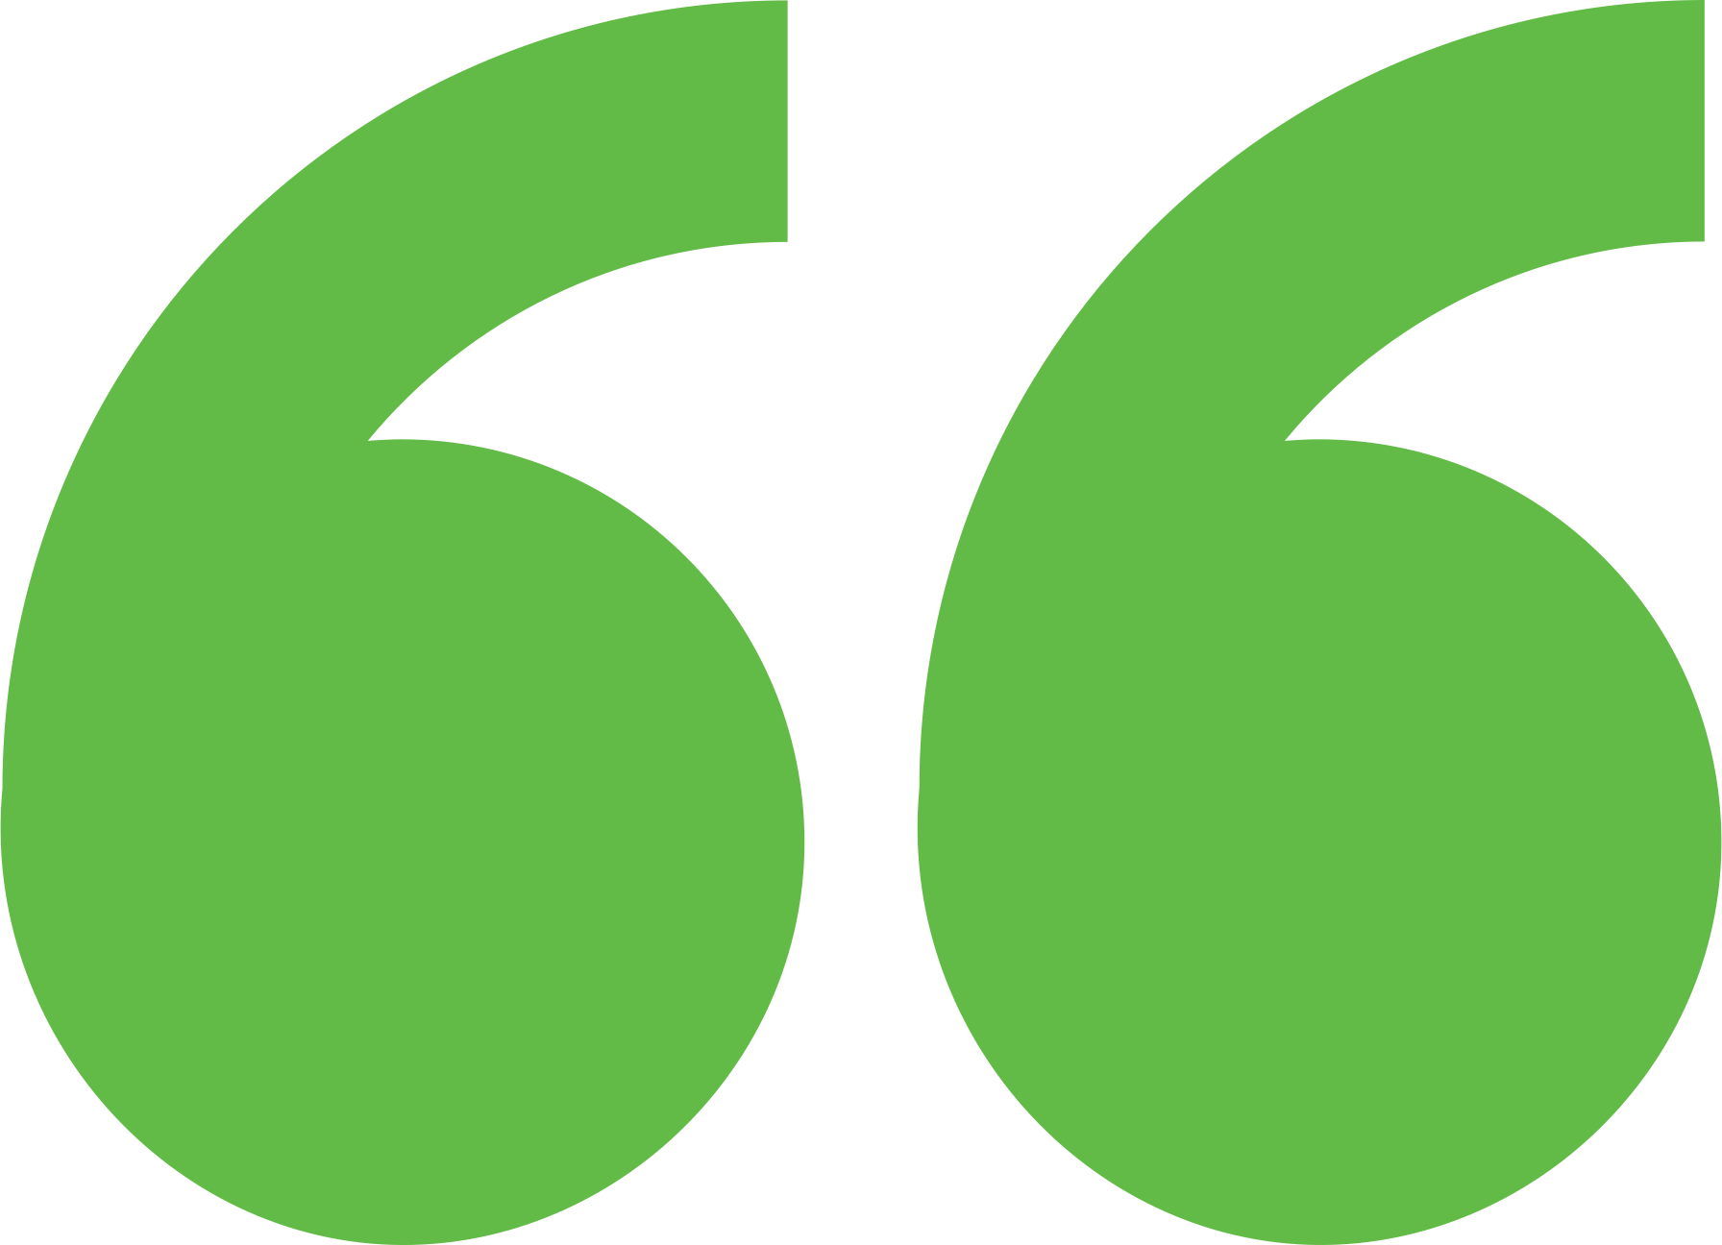 Impact

The technical assistance and engagement with experts were key to informing the design of the Qube2. A community member said, “Now the community understands green tech and solar-related endeavors are within reach of them and projects they can engage in. Connection is available with expertise. This is huge. Now we don’t have to worry about being taking advantage of by folks knocking on the doors—now we have government resources and experts that they can rely upon. We are currently making formal proposals to churches regarding solar on houses of worship. And we envision a meeting within the next three weeks with leaders with 300 churches regionally. We are going to propose to them on how they can work together to implement solar on these houses of worship. Money will be used to develop affordable housing projects.”

**Background**

Ann Arbor is a city of approximately 122,000 people located in southeast Michigan. The city and its residents are leaders in sustainability and climate action. Their A2ZERO Climate Action Plan outlines their just transition pathway to community-wide carbon neutrality by 2030. With equity as a focus, they are implementing strategies to improve home energy efficiency (EE) and electrify appliances. Toward this, the city wants to explore community geothermal heating and cooling to serve a variety of building types including rental and affordable housing. The city has applied to DOE’s Geothermal Heating and Cooling Design and Deployment program and garnered the support of City Council to pursue these projects, but they need to understand the concept’s feasibility in order to make a “go, no-go” decision.

Members of the Black Farmers’ Collaborative visited Jack’s Solar Garden in Colorado with NREL researchers to learn about agrivoltaics.

Photo by Dana-Marie Thomas, NREL

Background

Bealsville is a thriving, agricultural community in Hillsborough County, Florida. The community has several farming families that are interested in (1) potential opportunities at the intersection of farming and renewable energy and (2) broader clean energy opportunities. Bealsville farmers are considering a clean energy solution using agrivoltaics to make their farms more commercially competitive. Despite this excitement, the community is facing significant challenges in their goal of transitioning to clean energy, such as lack of knowledge and resources to acquire and utilize clean energy technologies, including a lack of economic and financial capacity. The Black Farmers’ Collaborative applied to C2C to receive technical assistance and expert guidance on the design of a greenhouse and aquaponics structure that serves as a self-contained greenhouse and a nighttime grow system all set within a conventional “row crop” farming space. Referred to as Qube2, the structure also would include a lighting system on the underside of the winged solar array. The baseline design will enable farmers to scale farms of different sizes (1‒30 acres) and the available greenhouse can be used year-round by multiple farmers through collaboration and agreements. The design facilitates crop rotation with different heights/needs throughout the year, such as greens, peas, berries, etc., and the objective is to maximize produce yields using a designed greenhouse. The Black Farmers’ Collaborative needed support understanding the potential benefits and challenges aroundQube2 and if there were alternative designs to consider.

Expert Match Team

**Dana-Marie Thomas,** Community Lead, Main Expert Match Point of Contact, NREL

**Jordan Macknick,** Researcher, Agrivoltaics Expert, NREL

**Brittany Staie,** Researcher, Agrivoltaics Expert, NREL

**Shanti Pless,** Researcher, Buildings Expert, NREL

Community Team

**Reverend Jerry Nealy,** Founder, President, and CEO, Black Farmers’ Collaborative Inc.

**David Carmena**, CEO, Carmena Enterprises

**Dale Wesson,** Dean, College of Agriculture & Food Sciences, Florida A&M University

For more information, visit:  
**energy.gov/eere/clean-energy-communities-program**

August 2024